**WHAT IS CARBON PRICING?**

Carbon pricing is an approach to reducing carbon emissions (also referred to as greenhouse gas, or GHG, emissions) that uses market mechanisms to pass the cost of emitting on to emitters. Its broad goal is to discourage the use of carbon dioxide–emitting fossil fuels in order to protect the environment, address the causes of climate change, and meet national and international climate agreements.

A key aspect of carbon pricing is the “polluter pays” principle. By putting a price on carbon, society can hold emitters responsible for the serious costs of adding GHG emissions to the atmosphere; these costs include polluted air, warming temperatures, and various attendants ills (threats to public health and to food and water supplies, increased risk of certain dangerous weather events). Putting a price on carbon can likewise create financial incentives for polluters to reduce emissions.

The benefits of carbon pricing are very significant. It is one of the strongest policy instruments available for tackling climate change. It has the potential to decarbonize the world’s economic activity by changing the behavior of consumers, businesses, and investors while unleashing technological innovation and generating revenues that can be put to productive use. In short, well-designed carbon prices offer triple benefits: they protect the environment, drive investments in clean technologies, and raise revenue.

**How Carbon Pricing Instruments Work**

Carbon pricing instruments can take many forms. A wide range of approaches and paths allows governments, businesses, and institutions to select the method best suited to the broader policy environment.

A carbon tax puts a direct price on GHG emissions and requires economic actors to pay for every ton of carbon pollution emitted. It thus creates a financial incentive to lower emissions by switching to more efficient processes or cleaner fuels (i.e., less pollution means lower taxes). This approach provides a lot of certainty about price because the price per ton of pollution is fixed; but it offers less certainty about the extent of emissions reduction.

An emission trading system (ETS)—also known as a cap-and-trade system—sets a limit (“cap”) on total direct GHG emissions from specific sectors and sets up a market where the rights to emit (in the form of carbon permits or allowances) are traded. This approach allows polluters to meet emissions reductions targets flexibly and at the lowest cost. It provides certainty about emissions reductions, but not the price for emitting, which fluctuates with the market.

Under a crediting mechanism, emissions reductions that occur as a result of a project, by a business or government, or policy are assigned credits, which can then be bought or sold. Entities seeking to lower their emissions can buy the credits as a way to offset their actual emissions. This approach requires a formally recognized third-party verifier to sign off on the emission reduction before it is credited.

Under a results-based climate finance (RBCF) framework, entities receive funds when they meet pre-defined climate-related goals, such as emissions reductions. Like crediting mechanisms, this approach requires the involvement of independent verifiers (in this case, to confirm that a goal has been met). By linking financing to specific results, RBCF facilitates carbon pricing and the creation of carbon markets, helps polluters meet climate goals, and stimulates private sector investment.

Under internal carbon pricing, governments, firms, and other entities assign their own internal price to carbon use and factor this into their investment decisions. Used as part of a broader decarbonization efforts, this approach encourages investment in low-carbon technologies and prepares institutions to operate under future climate policies and regulations. Internal carbon pricing generally takes two forms:

The first assigns a shadow price to carbon use—that is, determines its hypothetical cost. Entities calculate this price for their activities with the goal of managing climate risks and identifying opportunities in operations, projects, and supply chains to lower emissions and avoid locking their investments in long-lived high-carbon capital and infrastructure. For example, the World Bank Group has announced plans to apply a shadow carbon price to relevant investment projects using a price consistent with the recommendations of the High-Level Commission on Carbon Prices.

The second form is an internal carbon fee that companies voluntarily charge their business units for their emissions. Funds generated from this fee are channeled back into cleaner technologies and greener activities that support low-carbon transition.

**How to Structure an Effective Carbon Pricing Mechanism**

Although the design of carbon pricing schemes will vary depending on specific policy objectives and contexts, effective schemes share some common characteristics. The FASTER Principles for Successful Carbon Pricing, a guide jointly developed by the World Bank and the Organisation for Economic Co-operation and Development (OECD), distills six key characteristics of successful carbon pricing based on the practical experience of different jurisdictions:

Fairness. Effective initiatives embody the “polluter pays” principle and ensure that both costs and benefits are fairly shared.

Alignment of policies and objectives. Carbon pricing is not stand-alone mechanism. It is most effective when it meshes with and promotes broader policy goals, both climate and non-climate related.

Stability and predictability. Effective initiatives exist within a stable policy framework and send a clear, consistent, and (over time) increasingly strong signal to investors.

Transparency. Effective carbon pricing is designed and carried out transparently.

Efficiency and cost-effectiveness. Effective carbon pricing lowers the cost and increases the economic efficiency of reducing emissions.

Reliability and environmental integrity. Effective carbon pricing measurably reduces practices that harm the environment.

**Challenges in Designing Effective Carbon Pricing**

A well-designed carbon pricing mechanism can spur innovation and investments in low-carbon technologies that offer competitive advantage. But achieving the right design can also entail certain challenges:

Carbon leakage. Some schemes have had the effect of hindering business competitiveness. When there is an inconsistent patchwork of carbon pricing policies and regulations at the regional and global levels, the result can be carbon leakage—that is, the phenomenon by which carbon-intensive industries or firms shift operations to lower-cost jurisdictions. According to the Partnership for Market Readiness (PMR), however, this practice can be discouraged through targeted and well-designed policies—such as product or investment tax credits, research and development support, and business support services.

Policy overlap or inconsistency. Carbon pricing instruments can be significantly more effective if they are properly aligned with complementary policies, such as energy efficiency policies, emissions performance standards, and research and technology policies, among others. Policy makers must work carefully and deliberately to avoid potential overlap of and interaction between policy instruments, which could undermine the effectiveness of carbon pricing mechanisms. The Carbon Pricing Leadership Coalition (CPLC) has detailed information about the need for consistency across policies and measures to mitigate climate change.

Ineffective use of revenues. Carbon pricing instruments can raise significant revenues, but the effectiveness of many carbon pricing initiatives depends on how these revenues are spent. Revenues can be recycled to reduce other conventional taxes, protect lower-income households, support cleaner technologies, address fairness and competitiveness concerns, or channel public funds toward other public policy objectives. But as CPLC explains, each of these approaches has costs as well as benefits, and some are better suited to specific policy environments than others.

As of April 2019, 46 national and 28 subnational jurisdictions are putting a price on carbon.

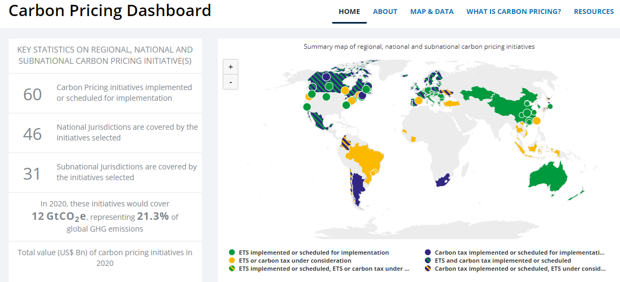

https://carbonpricingdashboard.worldbank.org/

**The Carbon Market in Australia**

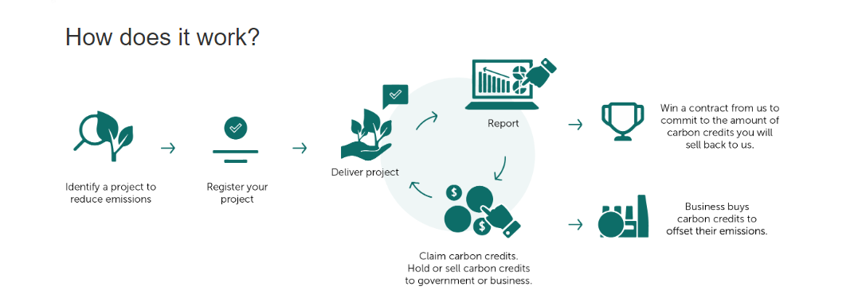

Take part in the Climate Solutions Fund

1. Find a project that suits you

To find a project type that works for you, search our project list.

2. Meet eligibility requirements

You will need to meet some general eligibility requirements.

See your chosen project for specific eligibility requirements.

3. Register your project

Set up a client portal account to register your project.

To have your project approved, you must provide a forward abatement estimate. This is an estimate of the number of ACCUs that will be issued.

4. Run project and complete compliance tasks

You must complete specific tasks for your project. These tasks include reporting, monitoring, record keeping and auditing.

There are also general reporting and auditing requirements.

5. Claim and sell ACCUs

Apply to claim ACCUs. This can be done as part of your reporting. ACCUs are then put in your ANREU account.

You can sell all or some of your ACCUs in an auction to the government through a carbon abatement contract or a private buyer through a commercial agreement

**Policy Context**

Australian climate change policy is focused on using market-based mechanisms to reduce emissions at the lowest cost (Commonwealth of Australia, 2008, 2011, 2014). The current incarnation of the Australian carbon market is an economy-wide voluntary carbon offset scheme under the Emissions Reduction Fund (ERF) (Commonwealth of Australia, 2014). The ERF has three components: crediting, purchasing and safeguarding emissions reductions (Commonwealth of Australia, 2014). To credit emissions reductions, the ERF used the infrastructure from the earlier Carbon Farming Initiative (CFI). This included retaining, but rebranding, the CFI’s method development and approval processes, offset projects and methods, legal arrangements, Australian Carbon Credit Units (ACCUs) and Clean Energy Regulator (the Regulator) (Commonwealth of Australia, 2014). The ERF purchasing component consists of the Regulator contracting offset projects through a reverse auction process. The ERF purchasing component was $2.55 billion of funding from 2014-15 to 2018-19 (Commonwealth of Australia, 2014). The Regulator selects offset projects based on price to enter into standardised contracts to buy ACCUs (Commonwealth of Australia, 2014). The safeguard mechanism provides a limit on emissions for the largest emitters based on historical baselines (Commonwealth of Australia, 2014). If liable firms exceed their baselines, they can purchase ACCUs to reduce their net emissions or face compliance actions (Department of the Environment, 2016).

**Carbon Market Scope**

This paper defines the Australian carbon market as the trading of ACCUs. This Australian carbon market has developed into one of the world’s largest offset trading schemes (Commonwealth of Australia, 2017b). It has its ERF primary market, where the Australian Government has paid or committed nearly $2.3 billion to 461 offset projects to deliver 192 million ACCUs (Clean Energy Regulator, 2018a). The Australian carbon market also has a growing secondary market with an estimated 2 million ACCUs available for trading (Climate Change Authority, 2017). Secondary market demand is driven by make-good obligations in ERF contracts, firm liabilities from the safeguard mechanism and limited voluntary market demand (Climate Change Authority, 2017).

**Carbon Market Performance**

The Australian carbon market contains a reasonably well-performing ERF but a languishing secondary market. The ERF is purchasing real and additional abatement at a reasonable cost (Climate Change Authority, 2017). The Regulator is administering the ERF reasonably well and with a high level of compliance (Australian National Audit Office, 2016, Climate Change Authority, 2017).

However, ERF projects have high transaction costs and ERF contracts are concentrated with large carbon service providers (CSPs) (Climate Change Authority, 2017). The ERF is also a complex scheme, particularly in its MRV, that favours aggregation and CSPs at the expense of its smaller participants (Burke, 2016; Verschuuren, 2017). Concerns are also emerging that the ERF purchasing component may be headed for a future ACCU shortfall, because the projects assigned to ERF contracts are decoupled from the ACCUs surrendered to the Regulator (Climate Change Authority 2017). A poorly functioning secondary market compounds this concern. The secondary market is opaque, illiquid and shallow (Climate Change Authority, 2017). This results in limited price discovery and investment signals as ACCU supply and demand are largely unknown (Climate Change Authority, 2017). To resolve these issues, more transparent secondary market information is required to strengthen the Australian carbon market (Climate Change Authority, 2017).

**Carbon Market Actors**

*Government*

The Government’s role in the market is split between a department that focuses on policy settings and the Regulator that administers the market. The Government department develops the policy settings, legislation and ERF methods (Climate Change Authority, 2017). The department is supported by an independent expert committee, the Emissions Reduction Assurance Committee, that advises on whether the ERF methods meet environmental integrity standards (Climate Change Authority, 2017). The Regulator is responsible for administering the ERF. This includes registering ERF projects, verifying ERF projects claims and issuing ACCUs, ERF purchasing, and any compliance and enforcement actions (Australian National Audit Office, 2016; Climate Change Authority, 2017). The Regulator also has responsibility for managing and administering the Australian National Registry of Emissions Units (ANREU) accounting system that underpins the Australian carbon market.

*Project proponents*

Project proponents have the responsibility and legal right to carry out ERF projects (Climate Change Authority, 2017). These project proponents generate ACCUs, can enter into ERF contracts with the Regulator and trade ACCUs on the ANREU.

*Carbon service providers*

Carbon service providers (CSPs) perform intermediary and advisory functions within the market. These roles include developing projects, advising project proponents through project registration and MRV processes and aggregating carbon projects (Climate Change Authority, 2017; Verschuuren, 2017). These CSPs also perform market making functions such as promoting the ERF, collecting market intelligence and brokering transactions (Climate Change Authority, 2017).

***The Clean Energy Regulator administers national carbon markets for:***

• The Emissions Reduction Fund, which has an additional $2 billion from the Climate Solutions Fund, increases carbon abatement and supply of Australian carbon credit units (ACCUs); and

• The Renewable Energy Target which operates through the creation of tradable large-scale generation certificates (LGCs), small-scale technology certificates (STCs) and associated statutory demand.

***The role of the Clean Energy Regulator***

The Clean Energy Regulator is responsible for key administrative tasks under the Emissions Reduction Fund including:

• registering projects

• running auctions

• managing contracts

• issuing Australian carbon credit units on achievement of emissions reductions.

The Clean Energy Regulator is an economic regulator and does not have any direct role or powers under our legislation to enforce work health and safety, environmental protection, or planning laws. However, we do share information with relevant regulators in appropriate circumstances.

Responsibility for meeting obligations to undertake a project in accordance with the law always rests with the business or individual concerned. If you are unsure of your legal responsibilities or believe that a business or person is not complying with the law, you should contact the relevant local authorities first.

The Department of the Environment and Energy will develop new methods for businesses to use to estimate emissions reductions.

The Department of Agriculture funds innovative research and on-farm trials of land sector emissions reduction and carbon storage opportunities that also seek to enhance productivity and sustainability. Research outcomes will help inform the development of methods under the Emissions Reduction Fund. The Department also administers the Extension and Outreach program, which delivers information about land sector emissions management to farmers, land managers and their key influencers. Through targeted activities, farmers are supported to make informed decisions about emissions management and participating in the Emissions Reduction Fund.

AusIndustry can provide advice on project development and energy efficiency and other emissions reduction opportunities.

References:

<https://medium.com/@robertgreenfieldiv/blockchain-enabled-carbon-credit-markets-1a195520f0e1>

<https://www.carbonpricingleadership.org/what>

<https://www.carbonpricingleadership.org/>

Hartmann, S. and Thomas, S., 2019. Applying Blockchain to the Australian Carbon Market. *Economic Papers: A journal of applied economics and policy*.

<http://www.cleanenergyregulator.gov.au/Infohub/CPM/About-the-mechanism>

http://www.cleanenergyregulator.gov.au/csf/Pages/How_it_works.html